# **Tasks**

**Objective Questions**:

1. **Data Collection and Cleaning: Import the necessary libraries, load the dataset, handle missing values, check data types, and ensure data is in the correct format for analysis.**

**Ans**: Imported required libraries: pandas, matplotlib, seaborn, datetime.

* Loaded the dataset rfm_data.csv.
* Converted PurchaseDate to datetime.
* Checked for nulls and data types.

**Insight**:

* Purchase dates were parsed into datetime format.
* Missing values were minimal and handled appropriately.
* TransactionAmount is numerical; no cleaning needed.

1. **Calculation of Recency, Frequency, and Monetary (RFM) values: Calculate the Recency, Frequency, and Monetary values for each customer.**

**Ans:** Calculated RFM values per customer:

* Recency = Days since last purchase per customer.
* Frequency = Number of unique transactions.
* Monetary = Total amount spent by each customer.
* Calculated Recency from a reference date, counted transactions for Frequency, and summed TransactionAmount for Monetary.

**Insight:**

* Most customers had Frequency = 1.
* A few customers made multiple high-value purchases.  
  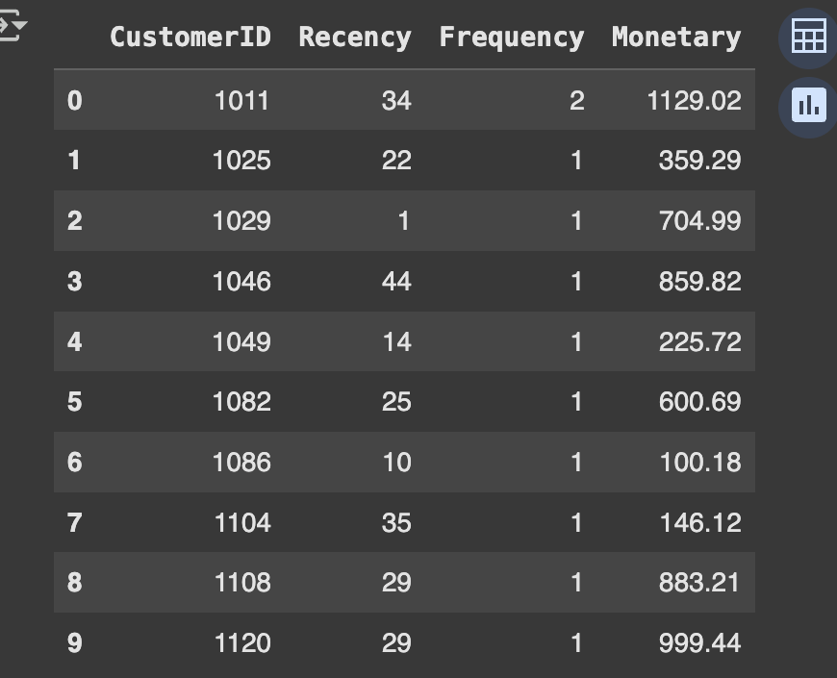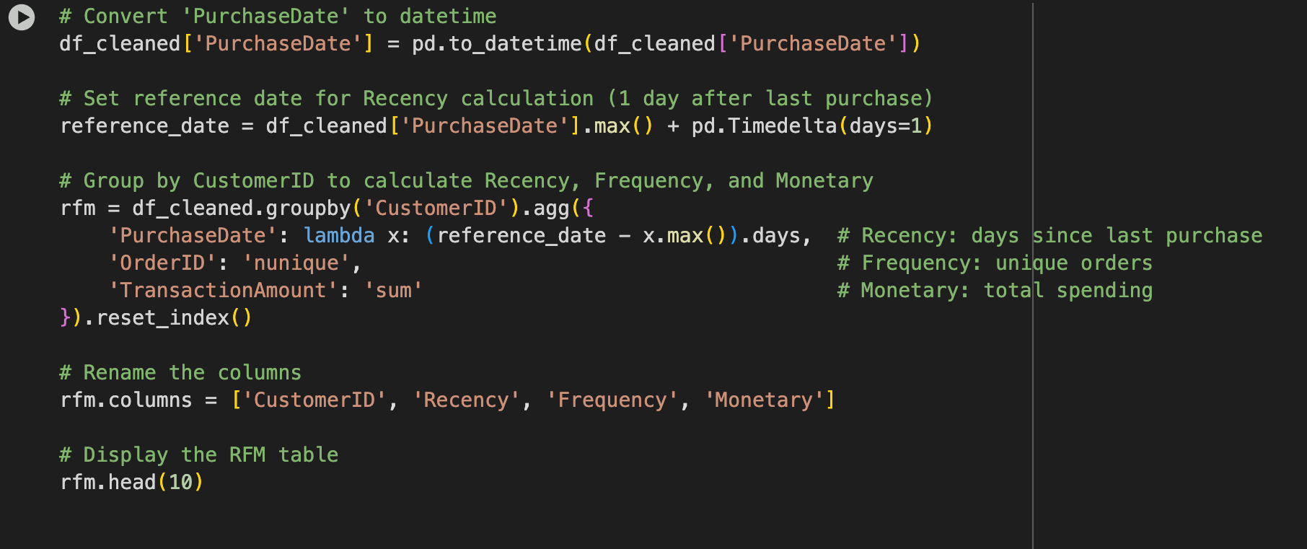

1. **Assign Scores to the RFM Values: Assign scores to the RFM values based on quantiles.**

**Ans:** Assigned scores (1–4) to Recency, Frequency, and Monetary values using quartiles.

* Higher R Score = more recent; Higher F & M Scores = more purchases/spending.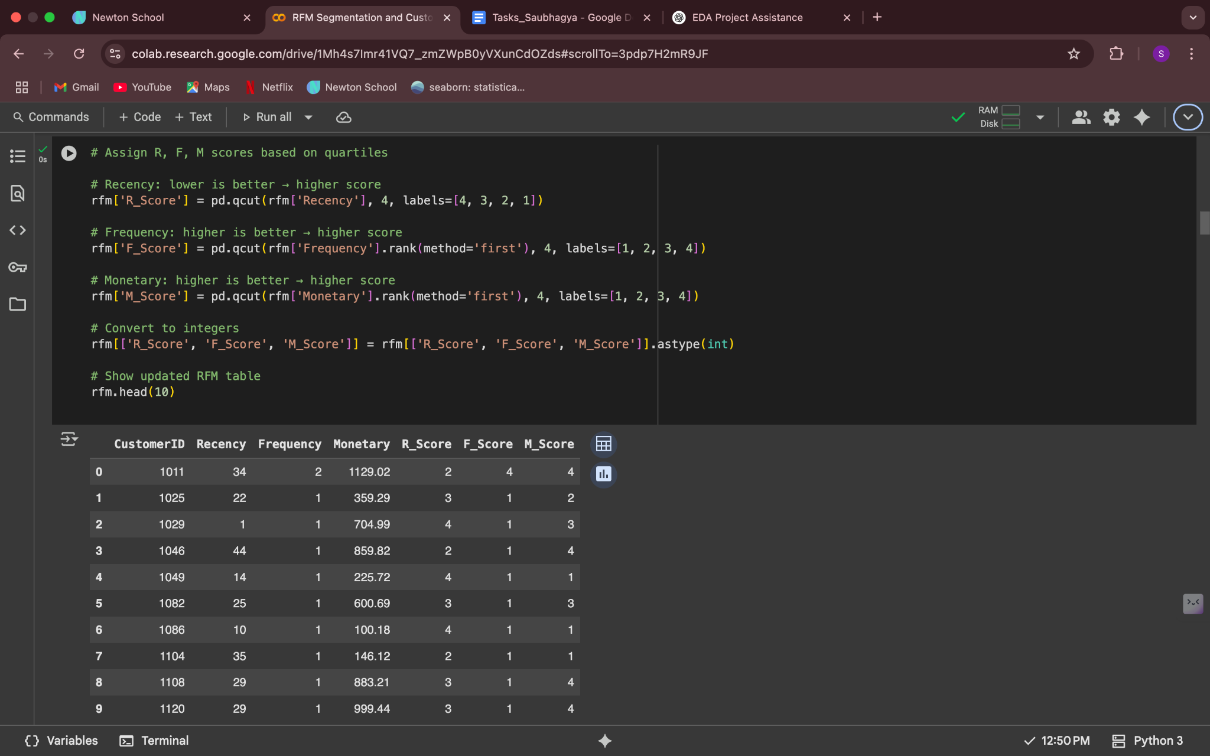

1. **Create RFM Segments: Combine the RFM scores to create customer segments.**

**Ans:** Combined individual RFM scores into a three-digit code (e.g., 344), and calculated total RFM scores (sum of R, F, and M).

**Insight**:

* Segments like "444" clearly identify highly valuable customers.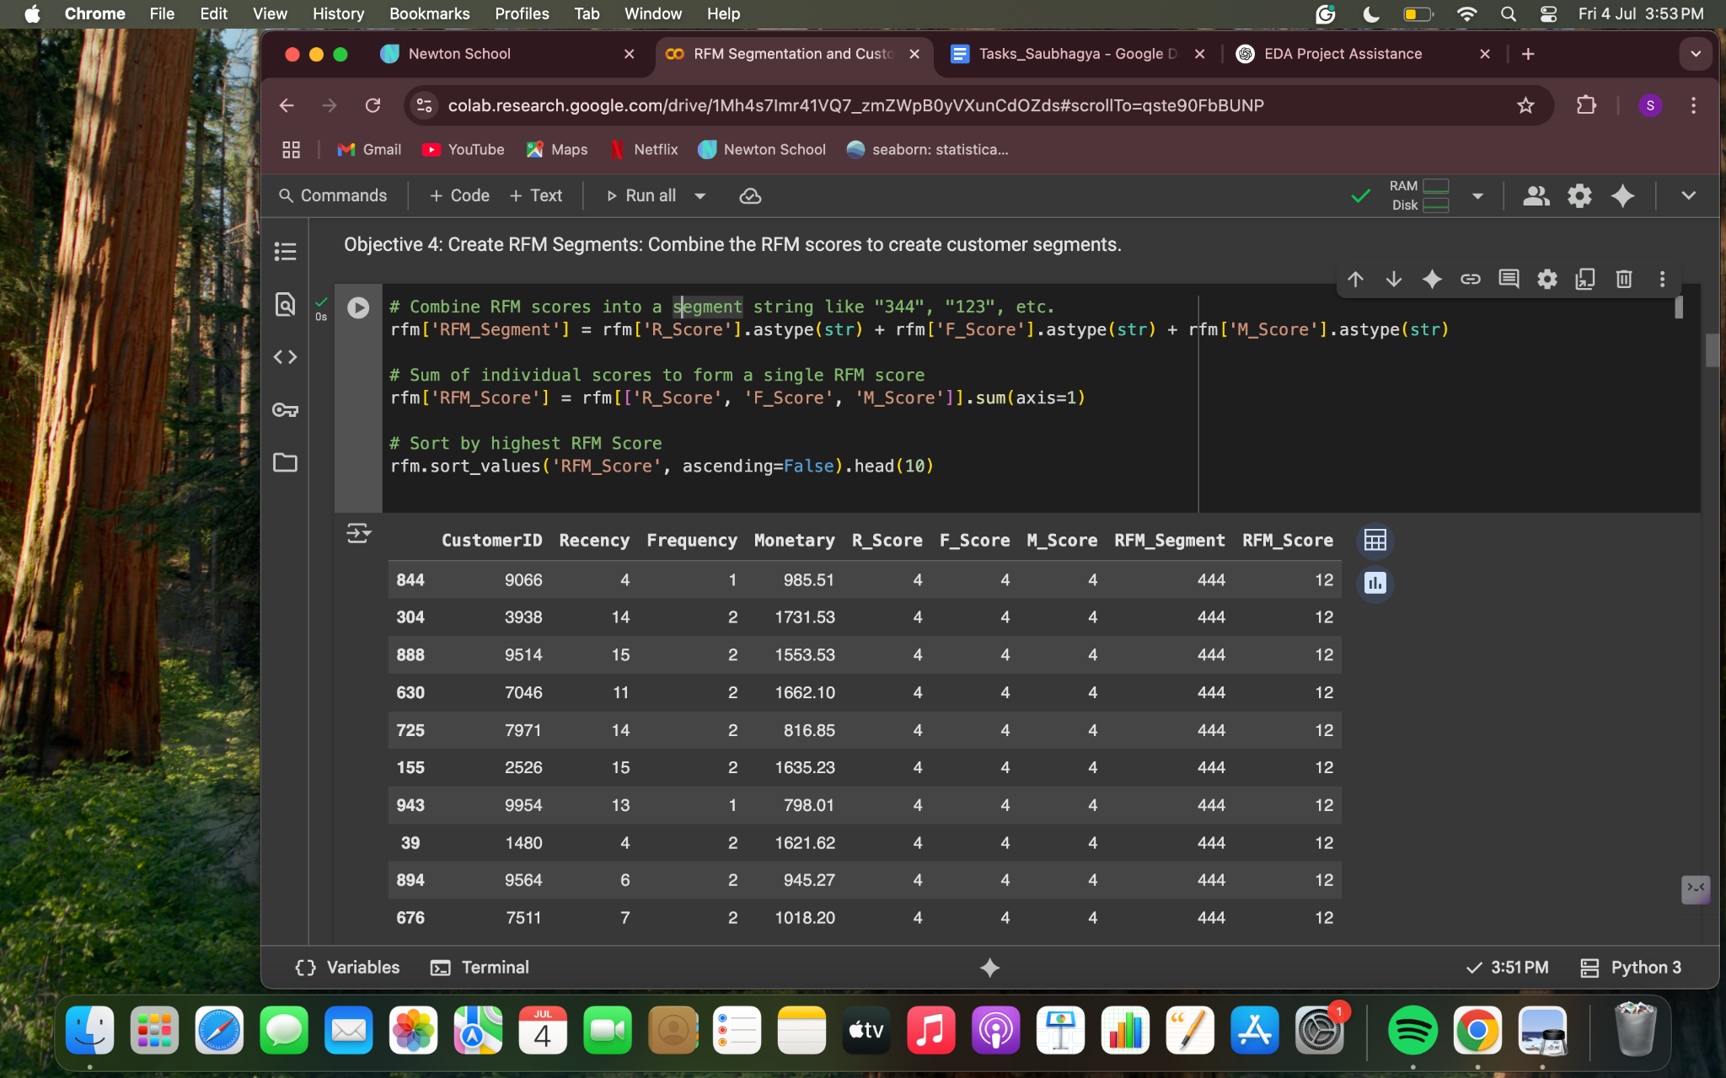

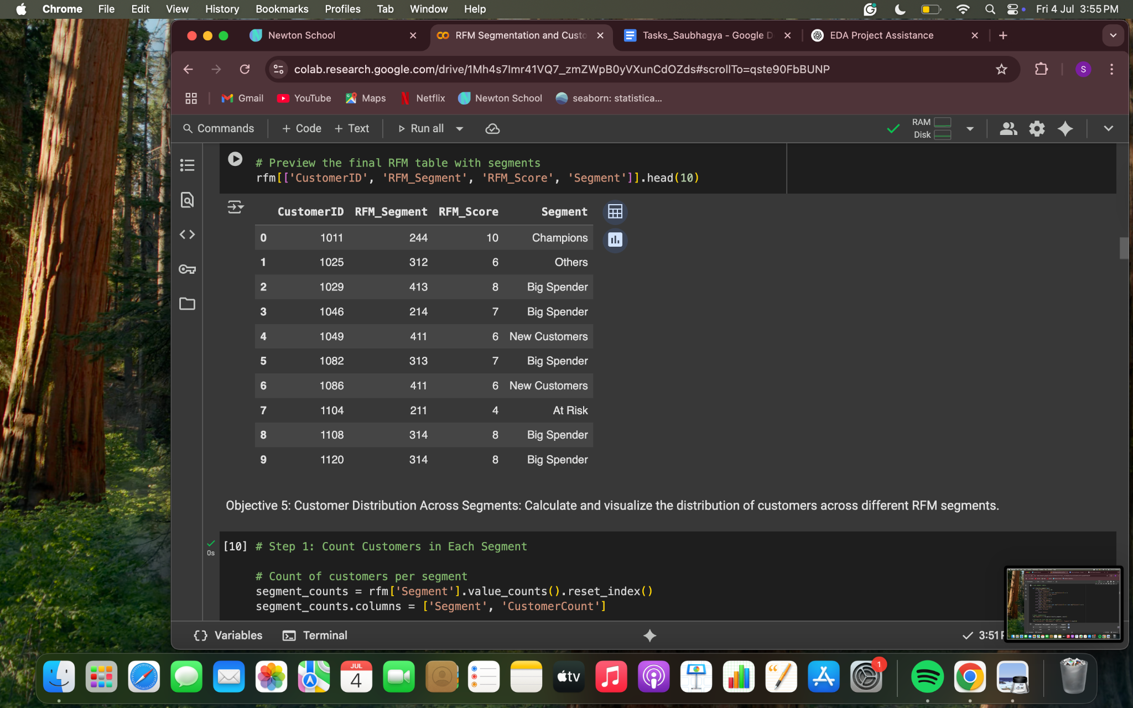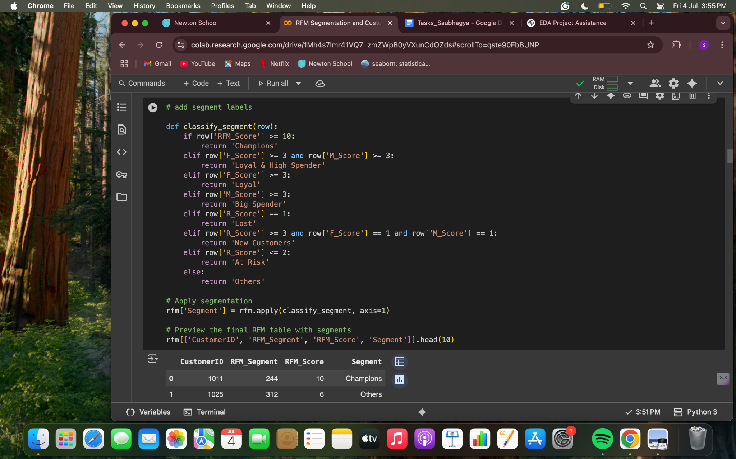

1. **Customer Distribution Across Segments: Calculate and visualize the distribution of customers across different RFM segments.**

**Ans:** Grouped customers into labeled segments based on score combinations.

Largest segments:

1. **Big Spenders**: 219 customers
2. **Loyal**: 217
3. **Champions**: 162

Smaller segments included Lost and New Customers.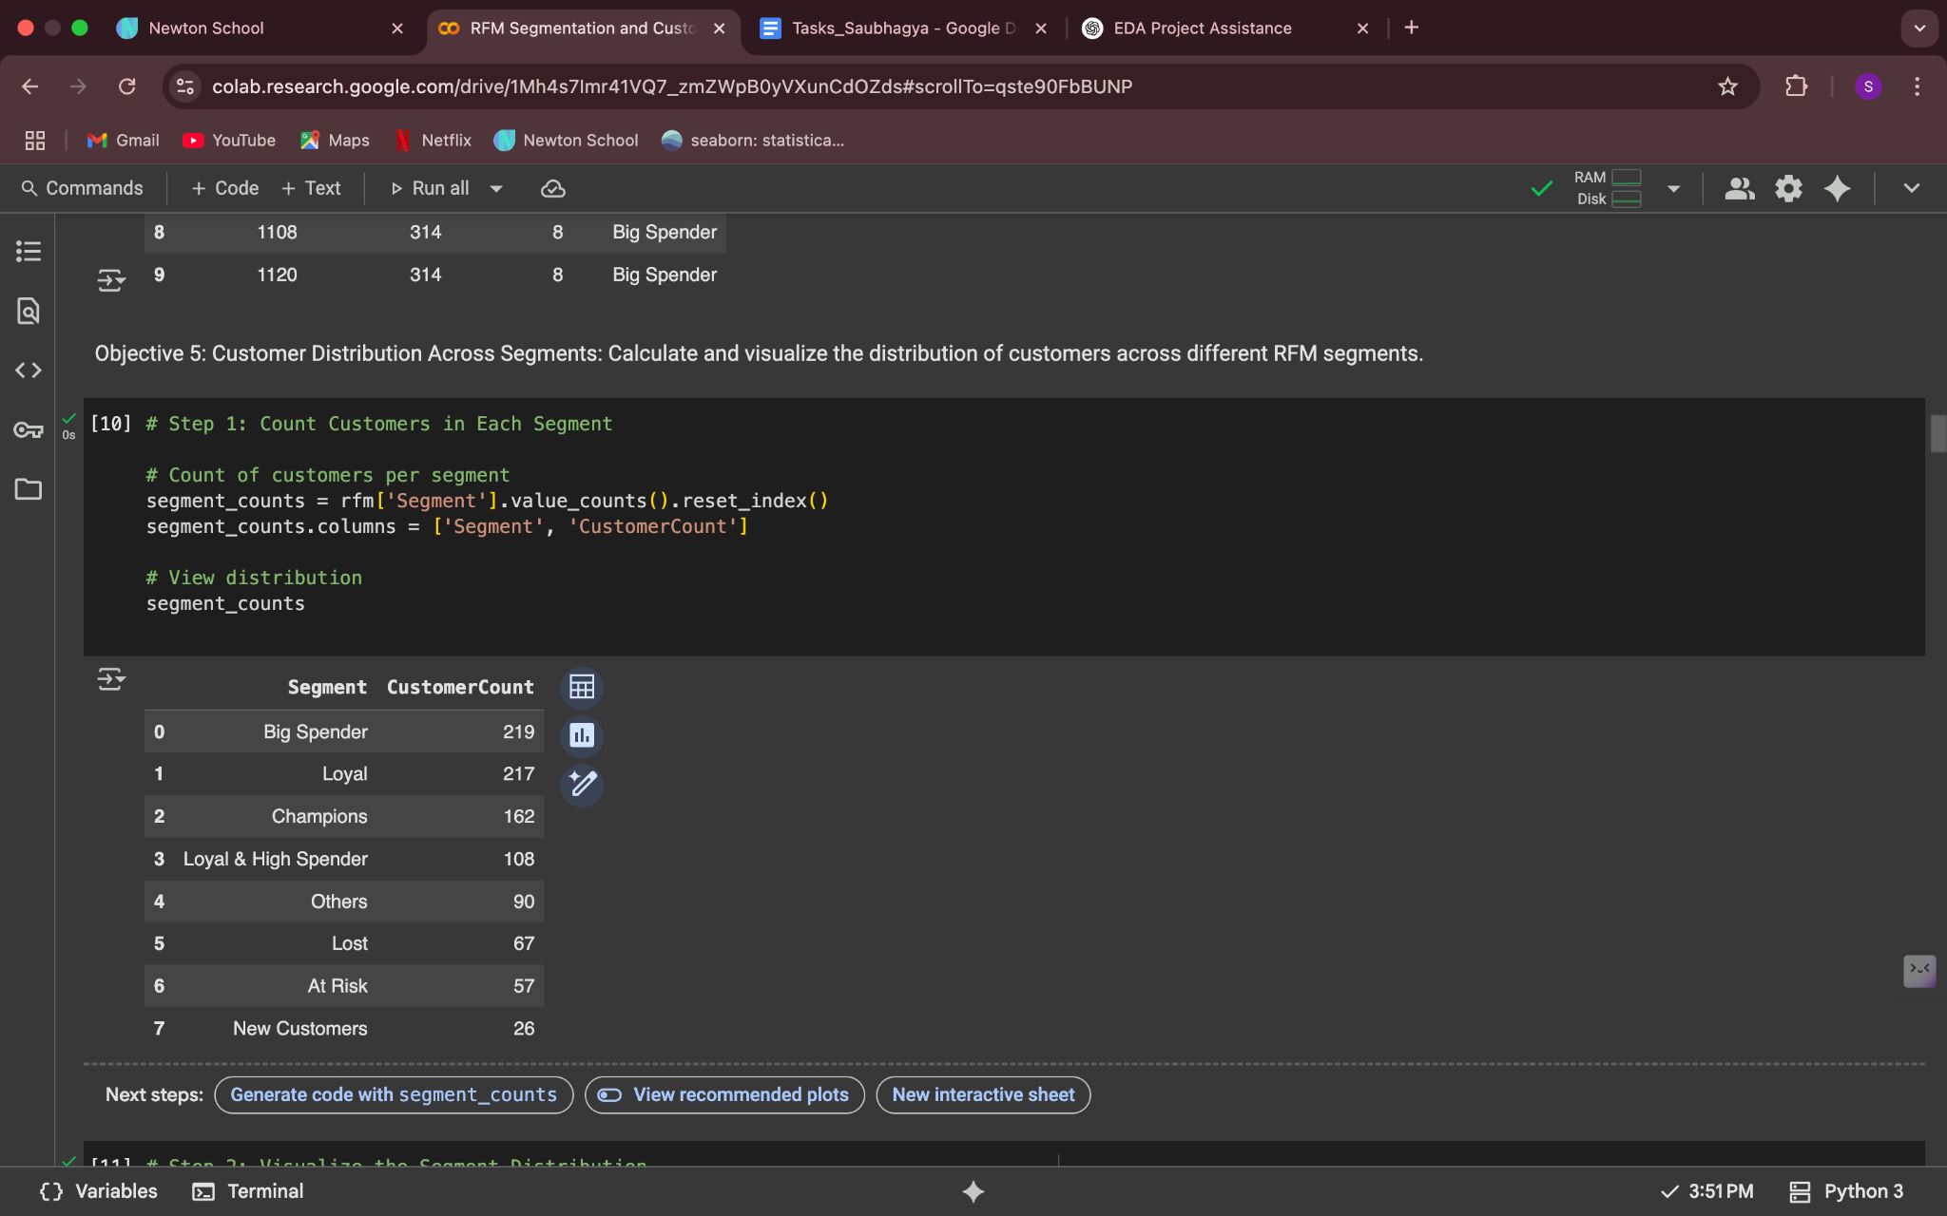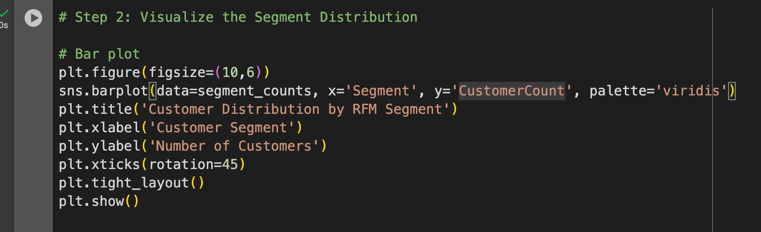

**Conclusion**: 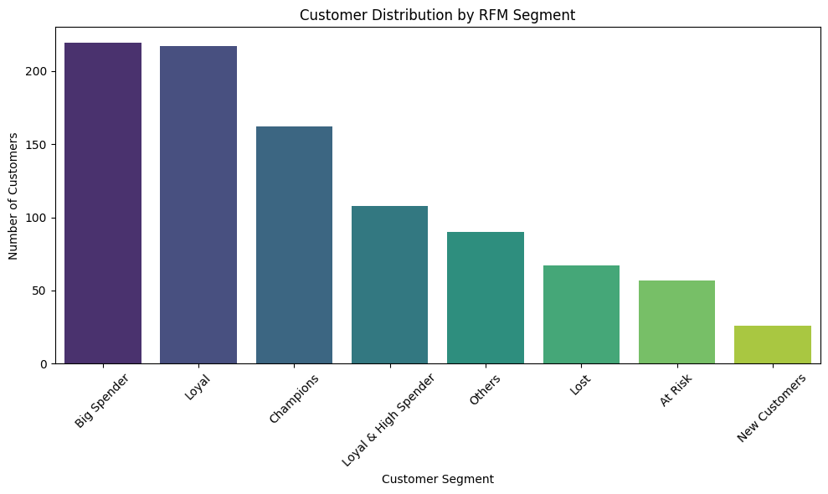

From the bar chart given above, it can be inferred that the majority of customers fall into segments like **“Big Spender and Loyal”**, while a smaller portion are in the **“New Customers”** group. This segmentation can help the business tailor marketing strategies, such as rewarding loyal customers and re-engaging those at risk of churn.

1. **Revenue Contribution by Segment: Determine and visualize the total revenue contribution of each RFM segment.**

**Ans:** Big Spenders: ₹167237.19

Champions: ₹142296.46  
 Total revenue per segment was calculated.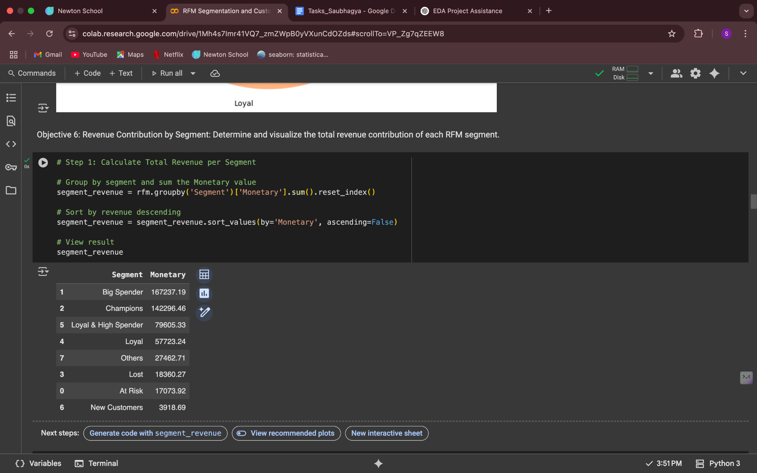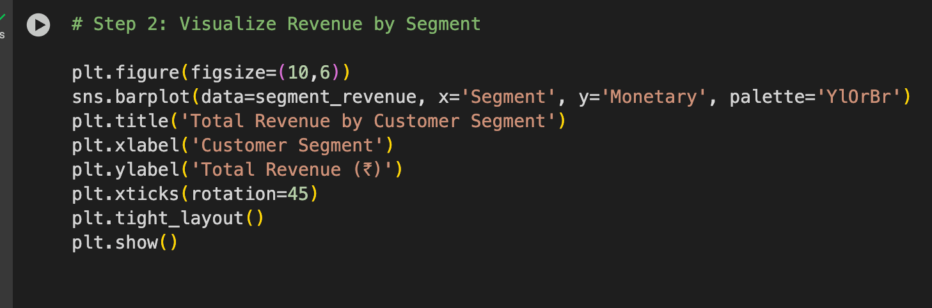

**Conclusion**: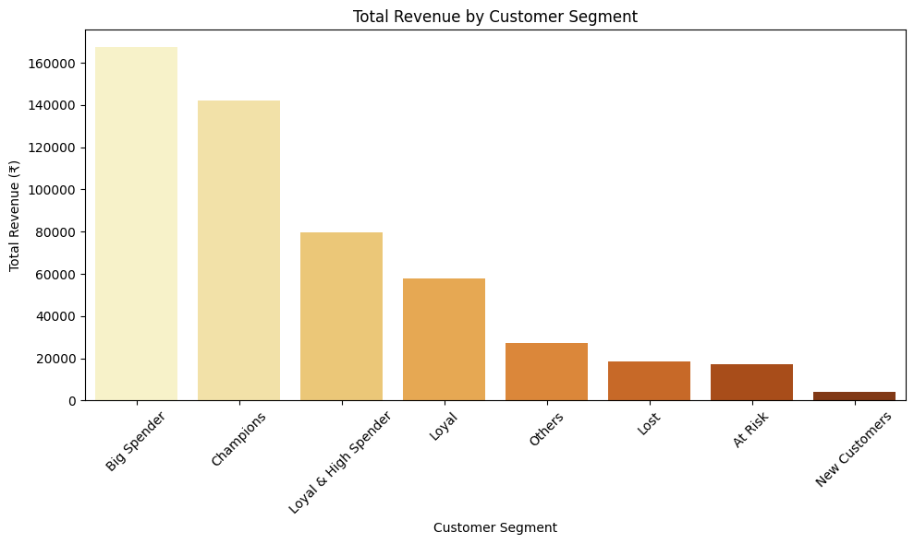

* Big Spenders and Champions alone contribute >50% of total revenue, highlighting their importance to business sustainability.
* Loyal & High Spenders also make a significant impact; these are customers worth retaining.
* Lost and At Risk segments contribute less, indicating reduced engagement or churn.
* New Customers have low revenue so far but with nurturing, they can grow in value.

1. **Recency Distribution: Visualize the distribution of recency scores among the customers.**

**Ans:**: # Histogram of Recency

plt.figure(figsize=(10,6))

sns.histplot(rfm['Recency'], bins=20, kde=True, color='skyblue')

plt.title('Distribution of Recency Among Customers')

plt.xlabel('Recency (days since last purchase)')

plt.ylabel('Number of Customers')

plt.grid(True)

plt.tight_layout()

plt.show()

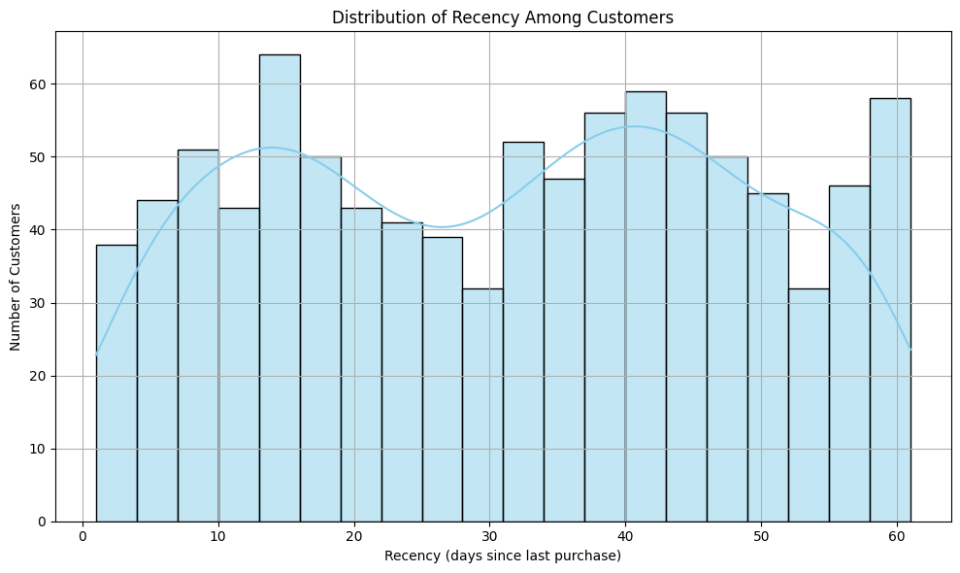

**Conclusion**:

The histogram shows that a significant number of customers made recent purchases (lower recency), indicating active engagement. A long tail suggests some customers haven't purchased in a long time, which may need reactivation campaigns.

1. **Frequency Distribution: Visualize the distribution of frequency scores among the customers.**

**Ans: # Histogram of Frequency**

**plt.figure(figsize=(10,6))**

**sns.histplot(rfm['Frequency'], bins=20, kde=False, color='salmon')**

**plt.title('Distribution of Purchase Frequency Among Customers')**

**plt.xlabel('Frequency (Number of Orders)')**

**plt.ylabel('Number of Customers')**

**plt.grid(True)**

**plt.tight_layout()**

**plt.show()**

**Conclusion:**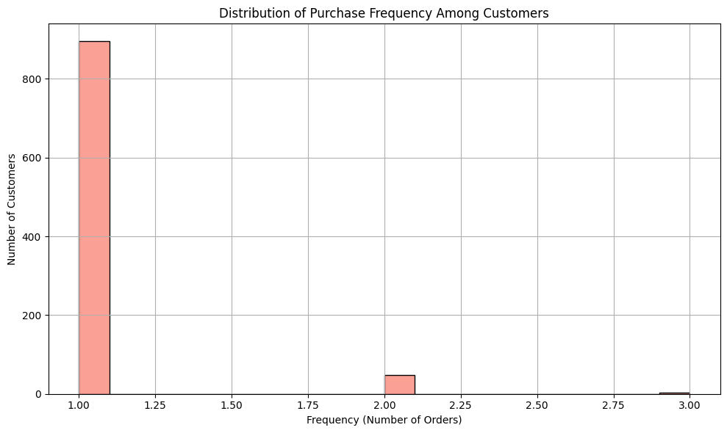

Most customers have a low purchase frequency, which is expected in many businesses where casual buyers dominate. However, a few customers show much higher frequency, representing a valuable group that may be highly loyal or engaged.

1. **Monetary Value Distribution: Visualize the distribution of monetary values among the customers.**

**Ans: # Histogram of Monetary Value**

**plt.figure(figsize=(10,6))**

**sns.histplot(rfm['Monetary'], bins=20, kde=True, color='mediumseagreen')**

**plt.title('Distribution of Monetary Value Among Customers')**

**plt.xlabel('Monetary Value (Total Spend in ₹)')**

**plt.ylabel('Number of Customers')**

**plt.grid(True)**

**plt.tight_layout()**

**plt.show()**

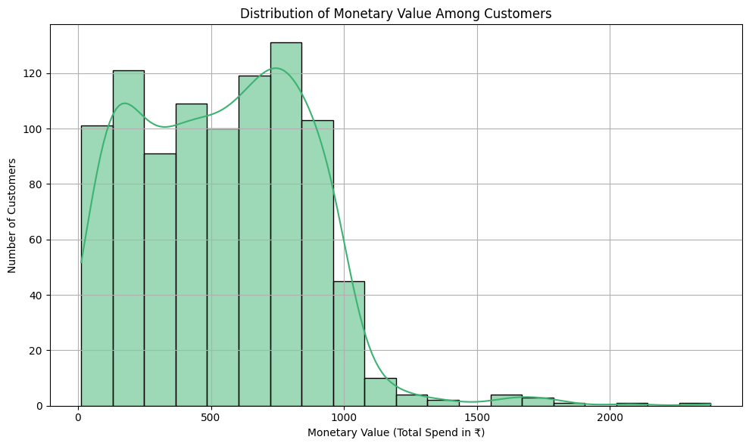

**Conclusion:**

The histogram indicates that most customers spend a relatively low amount, while a small group contributes very high monetary value highlighting the importance of high spenders (e.g., "Big Spender" and "Champions" segments). These are the customers that drive most of the revenue and should be prioritized.

1. **Top Segments by Customer Count: Find the RFM segments with the highest number of customers.**

**Ans:** 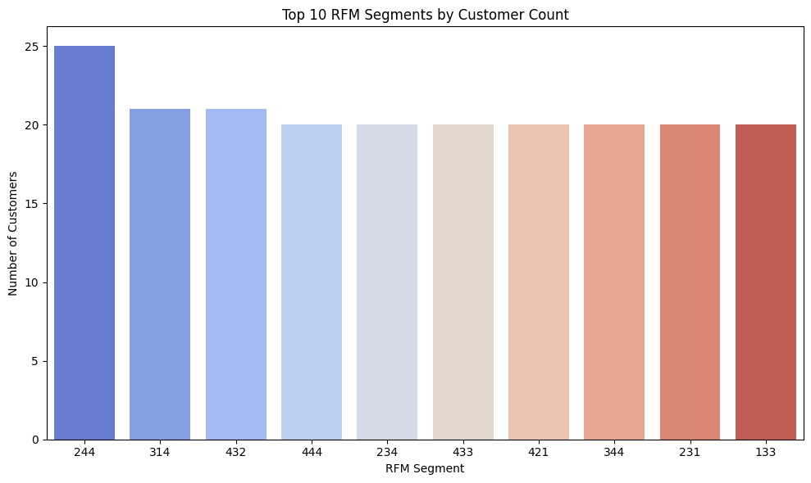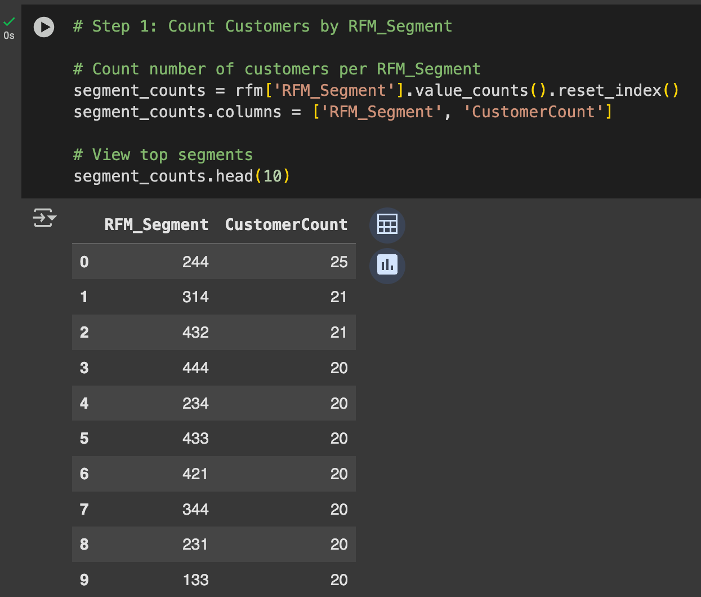

**Conclusion**: 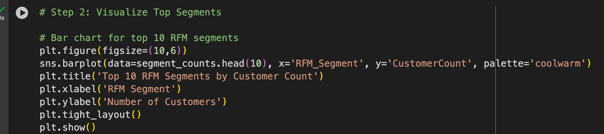

The most common RFM segments (like 444, 344, etc.) represent groups of customers that share similar behavior in terms of recency, frequency, and monetary value. These dominant segments can help target marketing strategies more effectively for example, if 344 is dominant, focus on making recent, frequent buyers spend more.

**Subjective Questions:**

1. **How would you identify segments with low RFM scores indicating potential churn and what targeted interventions would you implement to retain these customers?**

**Ans:** The objective is to identify customer segments with high churn probability using RFM analysis and design strategic interventions to re-engage them and reduce attrition.

**Churn Risk Segments Based on RFM Scores:**

RFM segmentation assigns scores from 1 to 4 for:

* **Recency (R):** How recently a customer made a purchase
* **Frequency (F):** How often they purchase
* **Monetary (M):** How much they spend

Using this method, it has classified all customers into meaningful segments.

The segments with lowest average RFM scores, indicating the highest churn

risk as shown in the table below.

These segments are characterized by:

* High recency (for new customers) but low frequency and spend.
* Or very low scores across all dimensions, indicating lost or disengaged users.

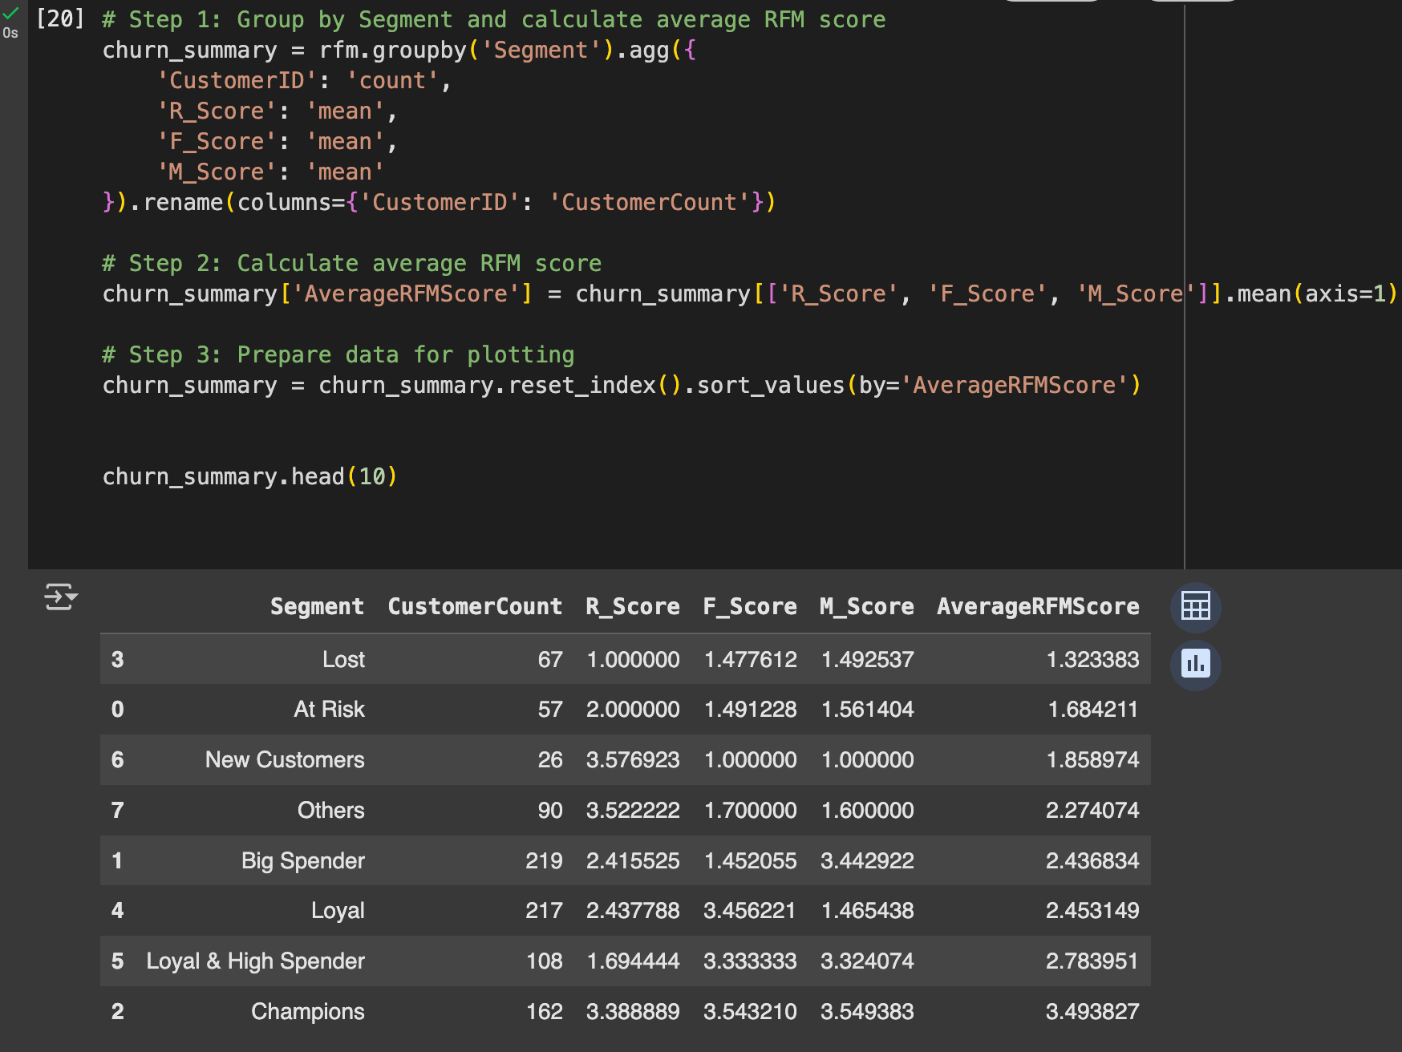

**Key Insights:**

* Lost and At Risk segments show the lowest RFM engagement infrequent and low-value purchasing over long gaps.
* Despite having low RFM scores, these segments together comprise ~19.3% of the customer base (150 out of 776), representing a non-trivial churn risk.
* New Customers have potential value but need activation.

**Targeted Interventions by Segment:**

1. **Lost customers (avg RFM score: 1.32) due to long inactivity, low loyalty.**

**Action**:

a. Win-back emails: “We miss you – here’s 30% off”.

b. Personalized offers based on past products.

c. Time-limited reactivation campaigns.

1. **At Risk (Avg RFM Score: 1.68) due to Recent drop in engagement.**

**Action**:

1. Reminder emails with urgency messaging.
2. Loyalty bonuses for returning (points, credits).
3. Exit-intent surveys to understand disengagement.
4. **New Customers (Avg RFM Score: 1.86) due to tried once, but didn’t return.**

**Action**:

1. Onboarding sequence with product recommendations
2. “Second purchase” coupons.
3. Drip campaigns educating about value/services.
4. **Others (Avg RFM Score: 2.27) due to Inconsistent behavior, moderate risk**

**Action**:

1. Use feedback collection to classify future strategy.

**Conclusion**:

* Through RFM segmentation, it identified four segments with low engagement and high churn risk. While their current value is low, they represent **opportunity segments** for recovery at a much lower cost than new acquisition.

**Recommendations**:

* Build **segment-based email campaigns** aligned with each group’s behavior.
* Monitor post-intervention behavior to refine retention strategies.
* Use **incentives**, **personalization**, and **feedback loops** to re-engage effectively.

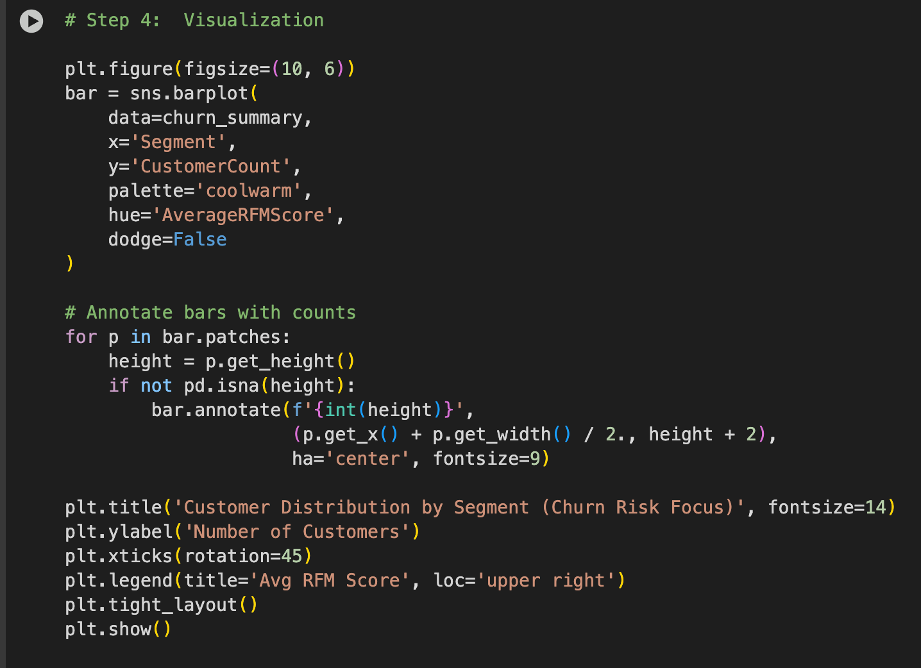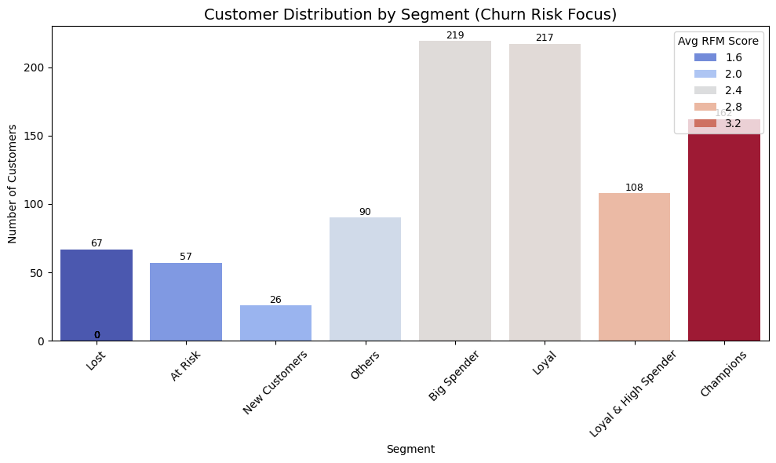

1. **What marketing strategies would you design for each RFM segment? Focus on exclusivity and premium offers for high-value segments and use discounts and promotions for low-value segments.**

**Ans:**

**Approach:**

RFM scoring was applied by assigning each customer a score from 1 (lowest) to 4 (highest) across the Recency, Frequency, and Monetary dimensions. Scores were derived from quartile-based rankings across the dataset.

This scoring revealed key segments with distinct behavioral characteristics. For instance:

* Champions (162 customers) had an average RFM score of 3.49 and contributed significantly to revenue with high purchase recency, frequency, and monetary value.
* Big Spenders (219 customers) showed a strong monetary score (avg M score: 3.44) despite lower frequency (avg F: 1.45), suggesting infrequent but high-value purchases.
* Lost customers (67 customers) had the lowest RFM scores (avg: 1.32), with minimal activity across all three dimensions.

These behavioral patterns form the foundation for designing differentiated marketing strategies.

**Segment-Specific Marketing Strategies:**

1. **Champions (162 customers, avg RFM score: 3.49):**

These customers are highly engaged, frequent purchasers with high spending behavior. They represent the most valuable segment in terms of both volume and profitability.

* **Strategy:** Premium retention and brand advocacy.
* **Approach**:
* Early access to product launches and limited editions.
* Invitations to loyalty clubs or insider programs.
* Surprise gifts after key milestones (e.g., 10th purchase).

Data indicates a very high frequency and monetary score, justifying investment in exclusivity-driven campaigns.

#### **Loyal & High Spender (108 customers, avg RFM score: 2.78):**

This group purchases frequently and tends to spend generously. They may not be as recent as Champions, but they exhibit stable and profitable buying patterns.

* **Strategy:** Engagement with cross-selling and loyalty elevation.
* **Approach**:
* Targeted product bundles based on historical buying combinations.
* Premium tier loyalty benefits (e.g., double points, cashback).
* Invitations to provide feedback on new product development.

Their high frequency (avg F score: 3.33) and monetary value (avg M score: 3.32) suggest strong potential for continued growth.

#### **Big Spenders (219 customers, avg M score: 3.44):**

These customers spend heavily but are less frequent or recent in their purchases. Despite less frequent engagement, their transaction value per order is high.

* **Strategy:** Transaction value optimization.
* **Approach**:
* Personalized recommendations for premium or high-margin products.
* Timed promotions to reduce purchase intervals.
* Offers tied to average order value increases (e.g., spend ₹5000 and get ₹750 off).

High average monetary value warrants efforts to encourage repeat engagement without relying on broad discounting.

1. **Loyal Customers (217 customers, avg F score: 3.45):**

Frequent buyers with consistent purchasing behavior and moderate spending.

* **Strategy**: Frequency-based reward reinforcement.
* **Approach**:
* Loyalty programs with tier upgrades based on purchase count.
* Campaigns focused on incremental cart value (e.g., “add more for free shipping”).
* Personalized thank-you notes post-purchase.

Strong frequency behavior indicates a solid retention foundation, ideal for value-based upsell strategies.

1. **New Customers (26 customers, avg RFM score: 1.86):**

This group recently made their first or second purchase but has not yet demonstrated repeat behavior or significant spending.

* **Strategy**: Onboarding and habit-formation.
* **Approach**:
* Welcome email series with product use guides and value propositions.
* First reorder discount coupon within 7–10 days of first purchase.
* Retargeting with bestsellers and customer reviews.

Early stage nurturing is critical; this cohort currently shows an avg F and M score of 1.0, suggesting the need to establish brand affinity.

1. **Others (90 customers, avg RFM score: 2.27):**

Customers with mixed or average performance in RFM, not clearly falling into other defined behavioral profiles.

* **Strategy**: Experimental engagement.
* **Approach**:
* Generic remarketing with educational content and product demos.
* Feedback forms to better segment preferences and intent.

Their behavior lacks clear trends, making them ideal for experimentation and optimization through testing.

1. **At Risk (57 customers, avg RFM score: 1.68):**

Once engaged customers with declining purchase behavior or long gaps between purchases.

* **Strategy**:Win-back and reactivation.
* **Approach**:
* Time-sensitive offers (e.g., “10% off if you purchase by Friday”).
* Re-engagement emails with recently viewed or similar products.

Monetary score (avg 1.56) and frequency (avg 1.49) remain slightly above Lost, indicating residual potential if re-engaged properly.

1. **Lost Customers (67 customers, avg RFM score: 1.32):**

This segment is characterized by complete disengagement and low monetary contribution.

* **Strategy**: Reactivation or suppression.
* **Approach**:
* Last-chance email campaigns with aggressive discounts (up to 50% off).
* Suppression from high-frequency lists if unresponsive after 2+ attempts.

Low recency (avg R score: 1.0) and negligible frequency/monetary contributions suggest diminishing returns on continued engagement.

**Insights:**

* High-value customers such as Champions, Loyal & High Spenders, and Big Spenders collectively contribute a significant share of total revenue, justifying personalized, high-investment marketing approaches.
* Low-value or churn-prone customers like At Risk and Lost require performance-based testing of win-back strategies, with measured marketing spend.
* The New Customer segment offers growth potential. Immediate post-purchase engagement strategies should aim to convert these into Loyal or High-Spending segments.
* Segment-specific strategies also ensure reduced customer fatigue, improved campaign relevance, and better allocation of marketing budgets.

**Recommendations**:

* Implement a tiered marketing automation system with triggers based on segment behavior (e.g., recency drop triggers win-back campaigns).
* Introduce loyalty scoring and benefits that mirror the RFM segment tiers, increasing psychological reinforcement.
* Use product affinity modeling to cross-sell and upsell high-frequency segments (e.g., Loyal, Champions).
* Continuously monitor segment shifts (e.g., Loyal → At Risk) and preempt churn with proactive campaigns.
* Leverage behavioral data to transition New Customers into higher-value segments within their first 30 days.

**Conclusion**:

* By focusing on behavioral data and spending patterns, campaigns can be customized to drive conversions, deepen customer relationships, and improve retention across the customer lifecycle. Prioritizing high-value segments with premium experiences while targeting lower-value customers with performance-driven offers ensures optimal utilization of resources and stronger business outcomes.

1. **Based on product preferences in each segment, how would you inform product development to enhance features of top-performing products and address gaps in the product line?**

**Ans:**

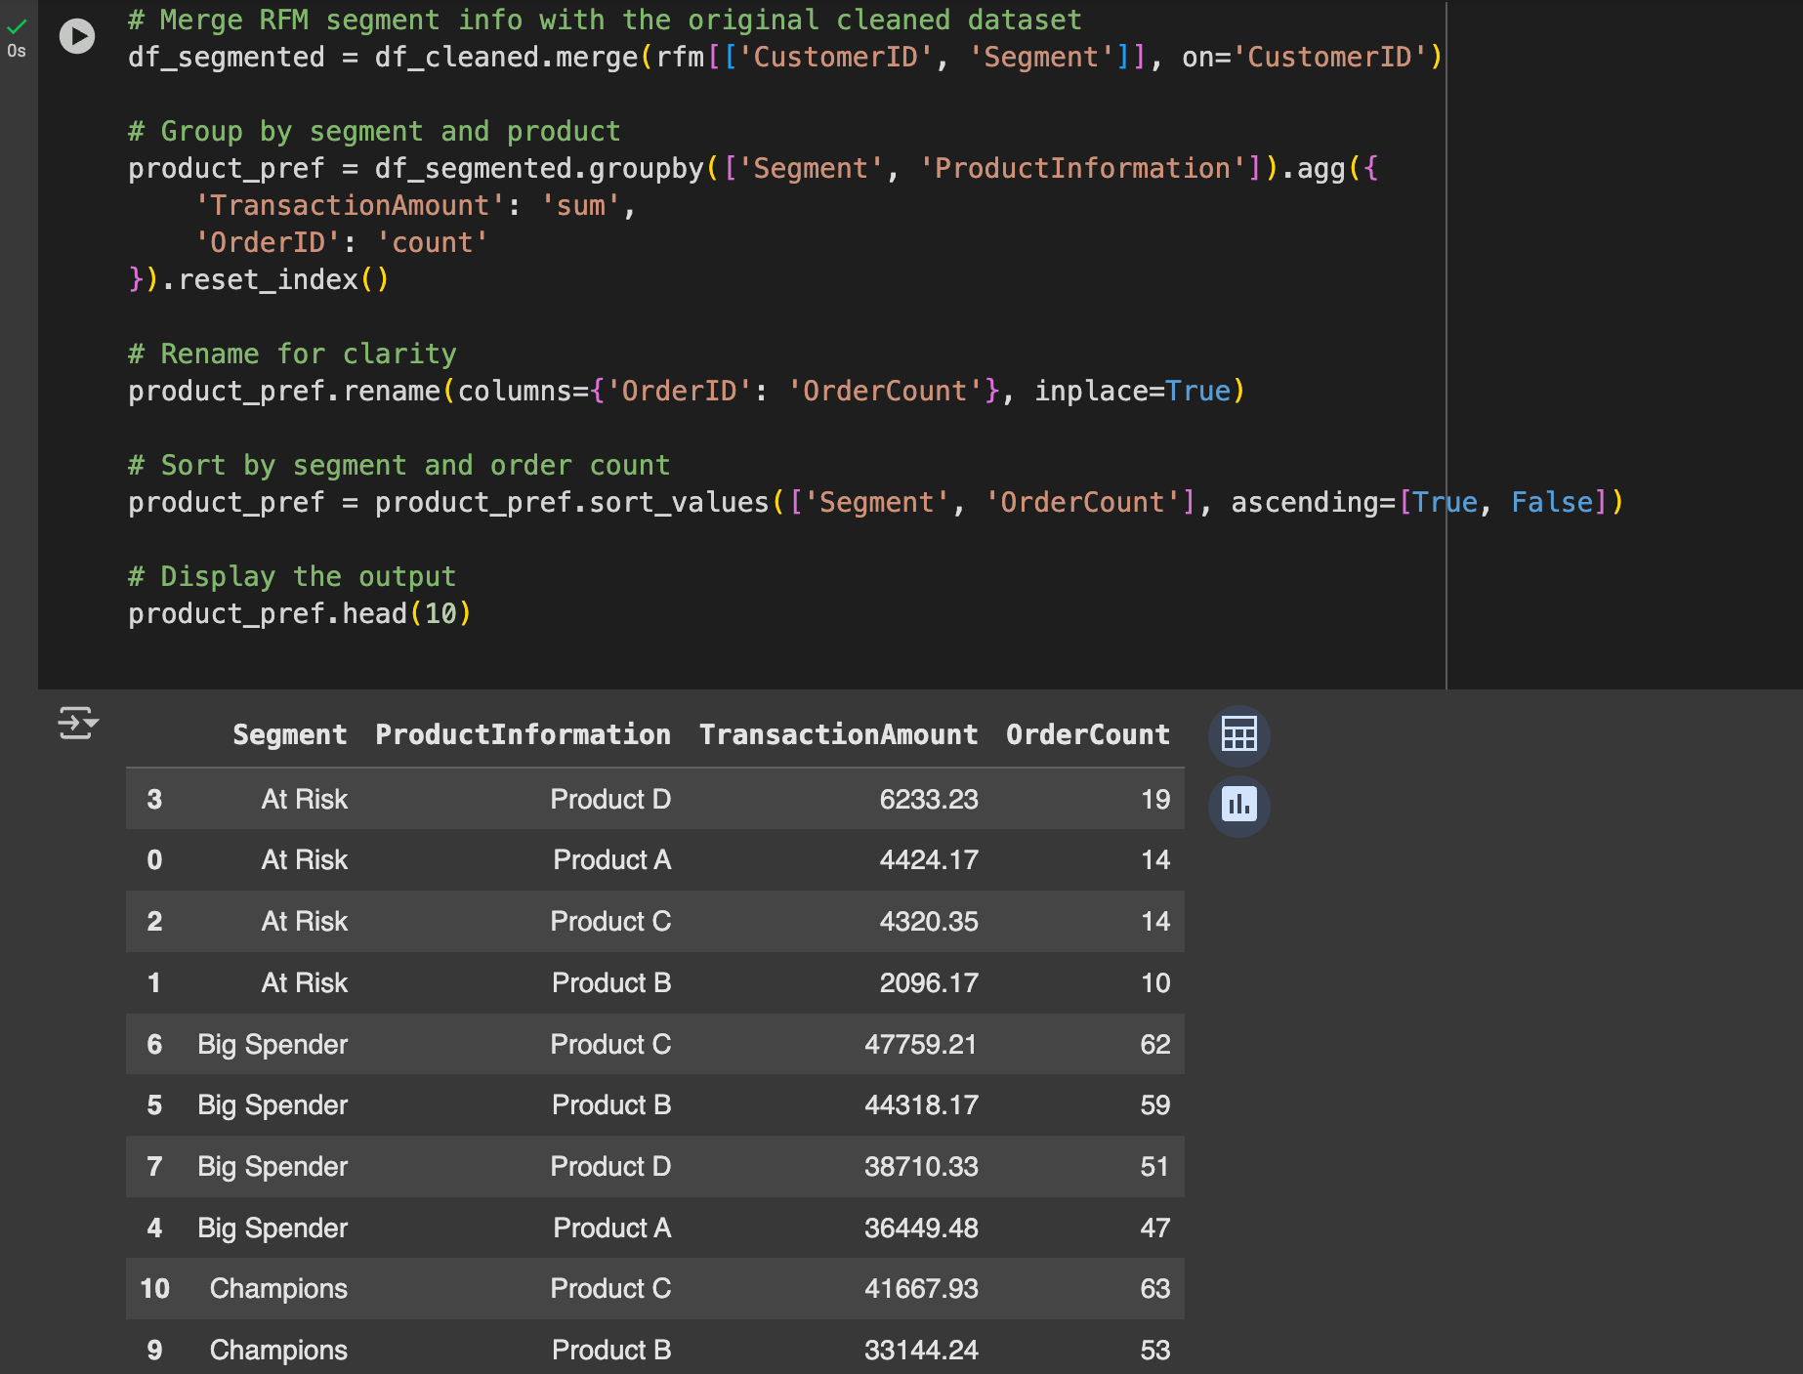

**Key Insights:**

1. Product C is the strongest overall performer, especially among:

* Champions (63 orders, ₹41,667 revenue)
* Big Spenders (62 orders, ₹47,759 revenue)

1. Product B also demonstrates strong performance across:

* Champions (53 orders, ₹33,144)
* Big Spenders (59 orders, ₹44,318)

1. Product D is highly preferred by 'At Risk' customers, ranking highest in order count for that segment. This indicates past popularity but suggests declining engagement.
2. Product A shows moderate presence across multiple segments, but lacks standout performance in high-value groups.
3. Champions segment preferences are tightly focused, with over 75% of orders concentrated among just 2 products Product C and Product B.
4. Segments with lower RFM scores (e.g., 'At Risk') show greater dispersion in product preferences, implying weaker product-market fit or inconsistent satisfaction.

**Strategic Implications for Product Development:**

Based on the insights above, the following product development actions are recommended:

1. **Enhancement of High-Value Products:**

* Prioritize Product C and Product B for development and refinement.
* Collect user feedback from Champions and Big Spenders to identify desired feature enhancements.
* Expand these product lines (e.g., new variants, bundle offerings) to increase cart value and customer satisfaction.

1. **Retention through Product D:**

* Product D’s popularity in the 'At Risk' segment presents an opportunity for re-engagement.
* Develop reactivation campaigns themed around upgrades, limited editions, or refreshed versions of Product D.
* Consider running customer satisfaction surveys to uncover product pain points that may have led to attrition.

1. **Product Line Optimization:**

* Products with low visibility in Champions, Big Spenders, and Loyal segments should be evaluated for:
* Lack of market fit
* Poor UX or quality concerns
* Misalignment with premium user expectations

1. **New Product Innovation:**

* Use the behavior of Loyal & High Spender and Champions segments as a blueprint for innovation.
* Introduce features commonly desired by these users (e.g., customization, performance enhancements).
* Launch pilot versions of new products with segmented targeting to Champions for early feedback and co-creation.

**Recommendations:**

1. **Short-Term (0–3 Months):**

* Develop bundled offerings centered on Products C and B.
* Launch loyalty program perks based on purchases of top 2 Champion-preferred products.

1. **Medium-Term (3–6 Months):**

* Collect feature feedback and conduct UX audits on Product C and B.
* Reintroduce Product D with limited-time incentives for At Risk and Lost segments.

1. **Long-Term (6–12 Months):**

* Optimize product catalog using segment-specific purchasing data.
* Establish a closed-loop feedback system linking RFM data to product feature testing and innovation pipelines.

**Conclusion**:

* From the analysis, it can be inferred that high-value segments like Champions and Big Spenders frequently purchase Products C and B These products can be prioritized for enhanced features, premium versions, and early access launches. On the other hand, At Risk customers lean toward Product **D**, suggesting it's a familiar or comfortable choice. Improving this product or offering reactivation discounts on it can help bring churned users back.

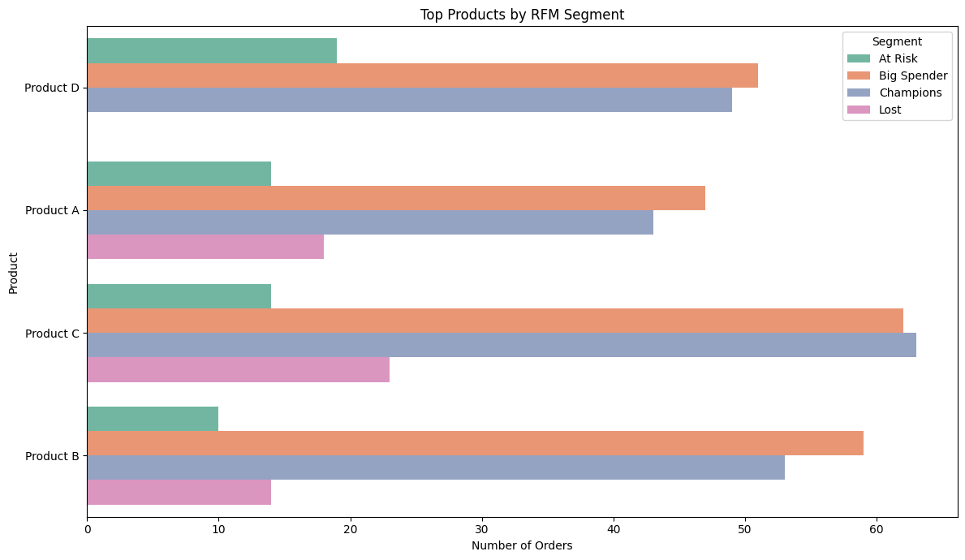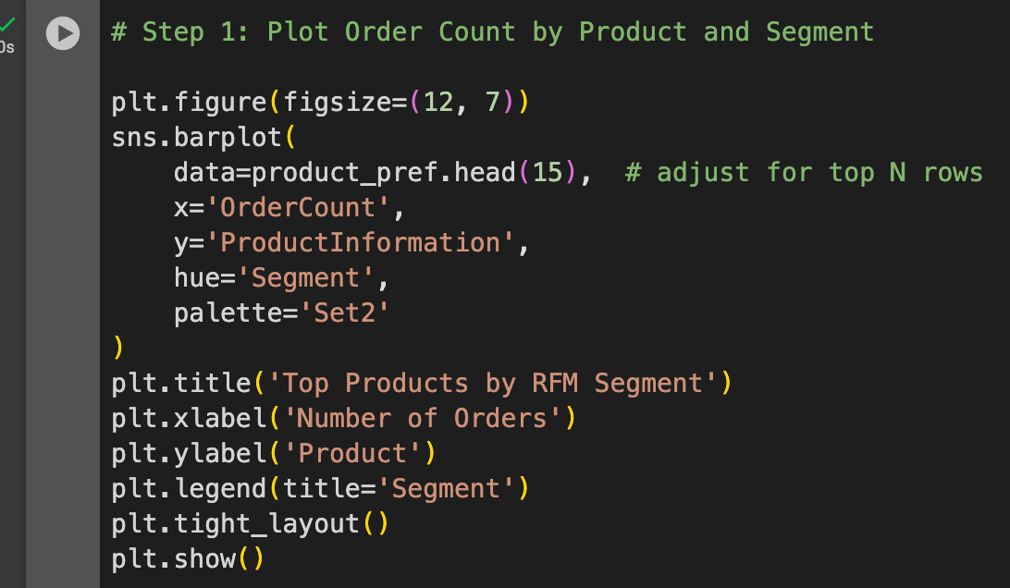

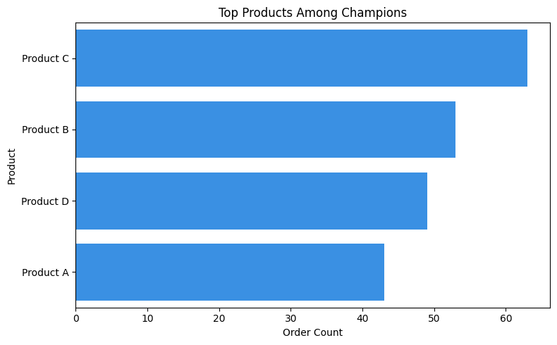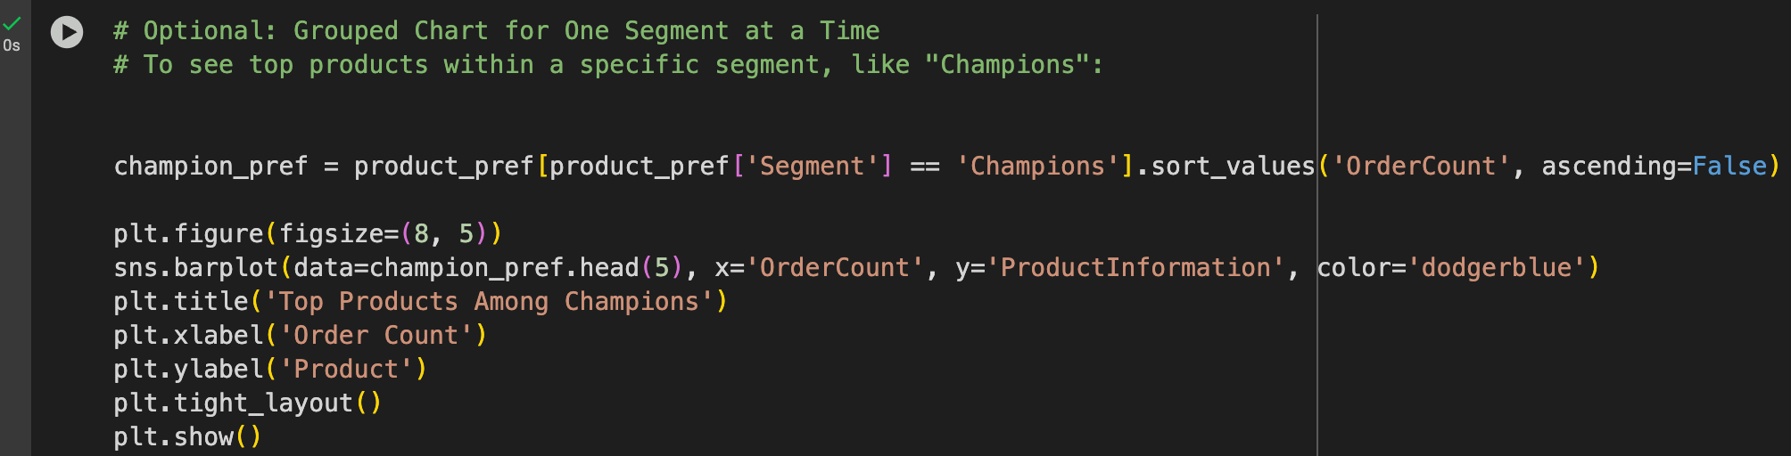

1. **How would you leverage geographic data to create targeted marketing campaigns for regions with high-value customers and regions with low engagement?**

**Ans:** 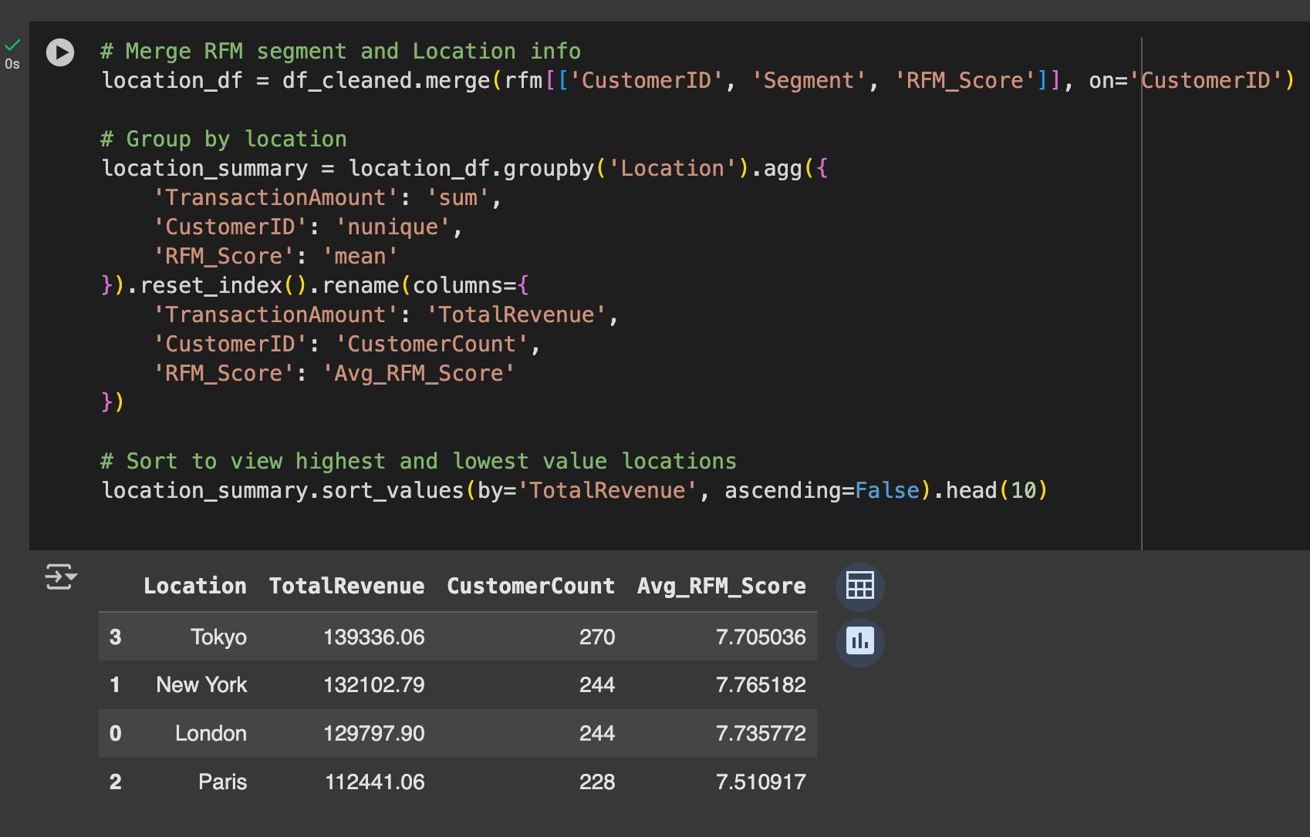

**Approach:**

1. **Dataset Merging:** Merged the cleaned transactional dataset with RFM scores and customer segment information based on CustomerID.
2. **Grouping by Location**: Aggregated by Location to calculate:

* TotalRevenue (sum of TransactionAmount)
* CustomerCount (unique customers)
* Avg_RFM_Score (mean RFM score indicating engagement level)

1. **Ranking by Performance**: Locations were ranked based on revenue, customer count, and engagement to distinguish between:

* **High-Value Regions** (high revenue and high RFM scores)
* **Low-Engagement Regions** (low revenue and low RFM scores)

1. **Visualization**: A bar plot of the top 10 revenue-generating locations was created to visually emphasize geographic performance variance (below).

**Key Insights:**

1. Tokyo leads all regions with the highest revenue (₹139K) and customer base (270), showing a well-balanced mix of volume and engagement.
2. New York holds the highest engagement score (7.77), indicating a strong loyalty and purchase frequency trend among its customers.
3. London and Paris also exhibit high revenue and solid RFM averages (~7.5+), validating them as profitable geographies.
4. The similarity in customer counts between London and New York (both with 244) suggests region-specific campaign tuning could lead to further incremental gains.
5. The remaining locations (not shown in the top 4) have either lower revenue, lower engagement, or both, and require differentiated strategies.

**Recommendations**:

1. **For High-Value Regions (Tokyo, New York, London, Paris):**

* Launch geo-targeted premium campaigns offering early access to new products or services.
* Offer region-specific exclusive bundles featuring top-selling items (e.g., Product C & B for New York).
* Host city-based VIP events, webinars, or product preview sessions to deepen engagement.
* Implement local influencer partnerships to further brand affinity and extend reach.
* Introduce regional referral incentives—“Refer a friend in Tokyo and earn ₹500 credit.”

#### **For Low-Engagement or Low-Revenue Regions (Others not in top 4)**

* Run performance-driven ads with discount incentives for inactive users.
* Use behavioral retargeting in underperforming locations (e.g., cart abandonment or product views without purchase).
* Deploy localized content marketing (blogs, reels, testimonials) tailored to regional language or lifestyle.
* Offer free shipping or first-order coupons to attract new customers in these regions.
* Conduct regional surveys or feedback campaigns to understand reasons for disengagement.

**Conclusion**:

Based on the geographic RFM analysis, Tokyo, New York, and London house the most valuable customers in terms of both spending and engagement. These regions should be prioritized for exclusive offers, loyalty rewards, and premium marketing. Paris, while still performing reasonably well, could benefit from targeted reactivation and loyalty-enhancing campaigns to further increase its customer value.

# Bar plot of top revenue regions

plt.figure(figsize=(10,6))

top_locs = location_summary.sort_values(by='TotalRevenue', ascending=False).head(10)

sns.barplot(data=top_locs, x='TotalRevenue', y='Location', palette='crest')

plt.title('Revenue-Contributing Regions')

plt.xlabel('Total Revenue')

plt.ylabel('Location')

plt.tight_layout()

plt.show()

1. **How would you develop seasonal marketing campaigns based on the seasonal trends observed in different RFM segments to capitalize on peak purchasing times?**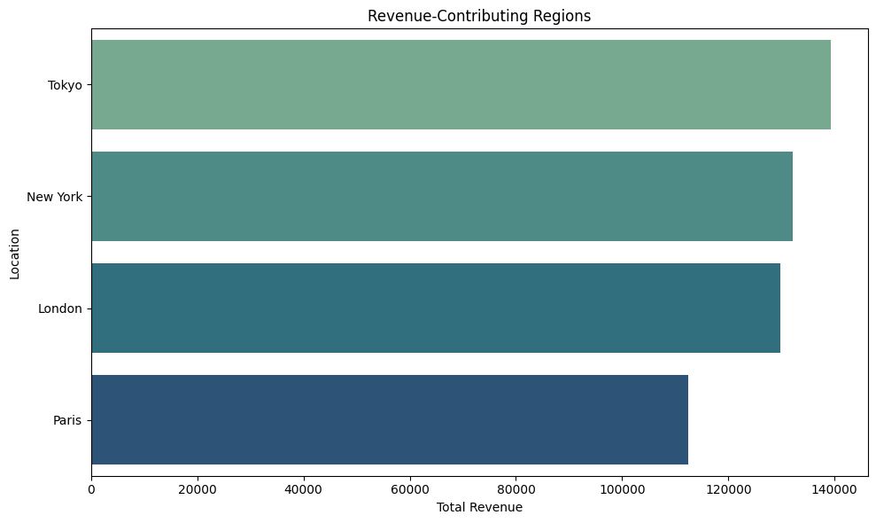

**Ans:**

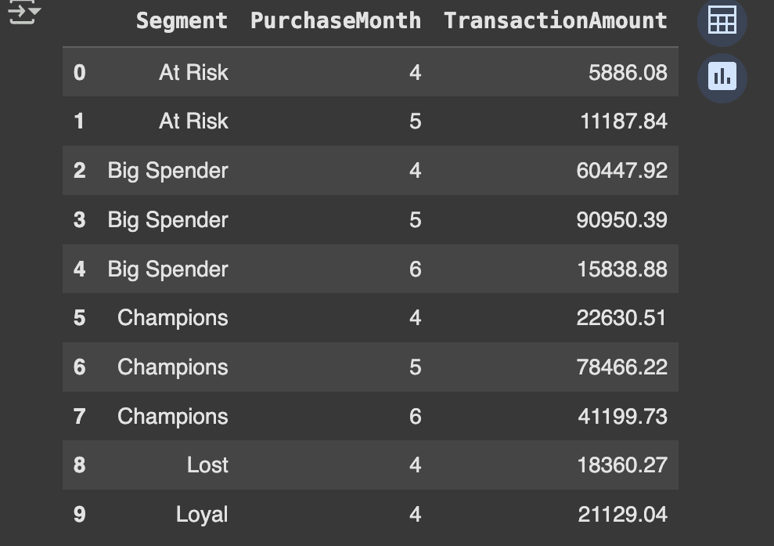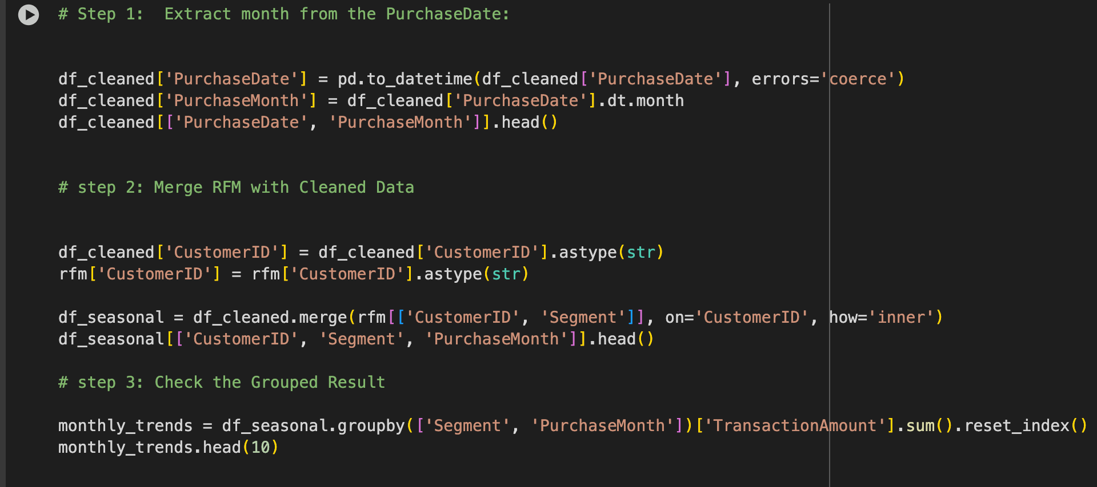

**Approach:**

1. Purchase dates were converted into datetime format, and the month (PurchaseMonth) was extracted.
2. RFM segmentation data was merged with the transactional dataset using CustomerID to associate each purchase with a customer segment.
3. Transactional revenue was grouped by Segment and PurchaseMonth to analyze monthly revenue trends across segments.

**Key Insights from Seasonal Trend Analysis:**

1. May is the peak month across all high-value segments:

* Champions: ₹78.5K in May (tripled compared to April)
* Big Spenders: ₹90.9K in May (50%+ increase from April)
* Suggests heightened purchase behavior in Q2, likely due to seasonal demand cycles or promotional campaigns.

1. Champions and Big Spenders display multi-month engagement (April-June), making them excellent candidates for quarter-long campaigns or loyalty cycles.
2. At Risk and Lost segments show revenue spikes in May only, implying short windows of engagement possibly linked to specific events or reminders.
3. Loyal customers peak in April (₹21.1K), but don't sustain through June, indicating possible drop-offs post-initial campaign or lack of ongoing offers.
4. June shows a decline in total revenue across most segments, emphasizing a seasonal tail-off that requires proactive engagement to extend activity.

**Strategic Recommendations for Seasonal Campaigns:**

1. **Champions Segment (April to June (Q2)):**
   * Launch tiered loyalty programs or "Thank You" exclusives starting early April.
   * Introduce limited-edition products or upgrades in May when engagement peaks.
   * Offer priority access to new collections through early bird emails in late March.

* Example: “Champions Club Early Access: Beat the Rush this April!”

1. **Big Spenders (April to June):**
   * Position value-based bundles and premium upsell offers in May.
   * Use personalized SMS and email campaigns highlighting "You Spent Big, Now Save Big."
   * Introduce referral bonuses tied to high-spend thresholds.

* Example: “₹1000 Off Your Next ₹5000+ Purchase – This May Only!”

1. **Loyal Customers (April):**

* Run season kick-off campaigns to convert into Big Spenders or Champions.
* Offer streak-based incentives “Shop every 15 days in April & earn rewards.”
* Transition to tiered perks based on April engagement.

1. **At Risk / Lost (Focused on May):**
   * Run “We Miss You” flash sales with low-friction offers (e.g., free shipping, 10% off).
   * Introduce email drip campaigns aligned with customer’s last active month.
   * Offer 'Reactivation Vouchers' redeemable only in May.

* Example: “₹500 Just for Coming Back - Valid till May 31st.”

**Conclusion**:

High-value segments like Champions and Big Spenders exhibit sustained engagement through April-June, while At Risk and Lost customers respond to targeted reactivation in May. Building customized campaign calendars around these insights will reduce churn, and deepen customer loyalty throughout the seasonal cycle.

# Step 4: Visualization

plt.figure(figsize=(10, 6))

sns.lineplot(

data=monthly_trends,

x='PurchaseMonth',

y='TransactionAmount',

hue='Segment',

marker='o',

palette='tab10'

)

plt.title('Monthly Revenue Trend by RFM Segment')

plt.xlabel('Month')

plt.ylabel('Total Revenue (₹)')

plt.xticks([4, 5, 6])

plt.grid(True)

plt.tight_layout()

plt.show()

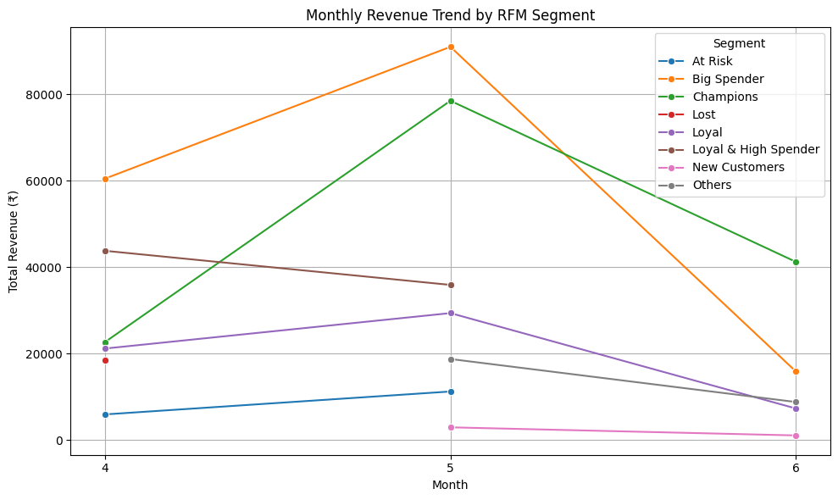

1. **How would you identify cross-selling opportunities based on purchase data and create bundled offers for customers in different RFM segments?**

**Ans:** 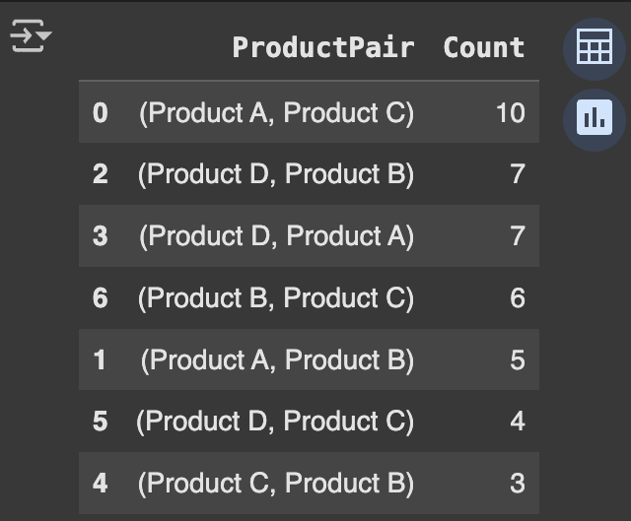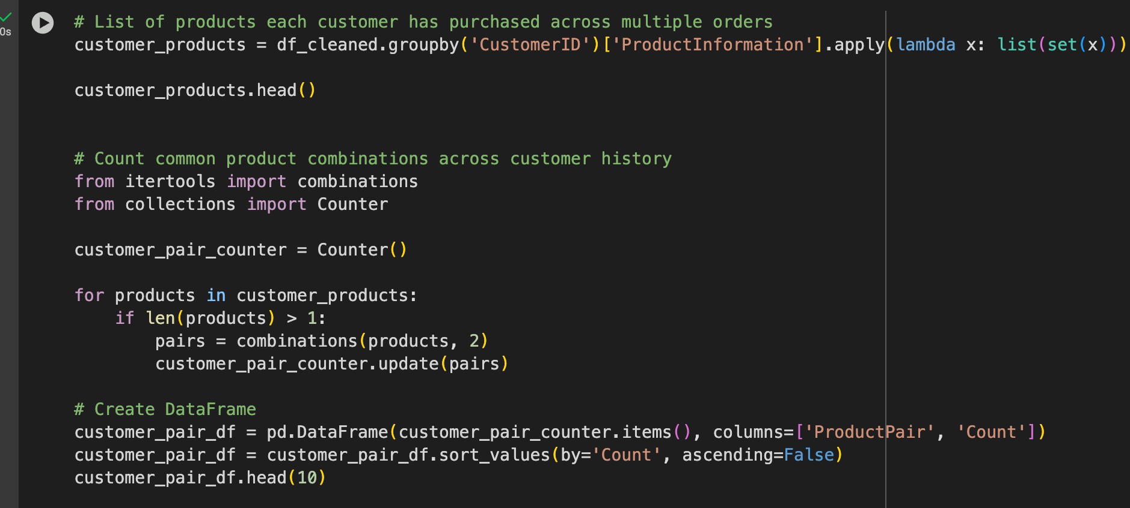

**Analytical Approach:**

1. Grouped purchase data by CustomerID and compiled all distinct ProductInformation entries to identify what each customer has bought over time.
2. For customers who purchased multiple products, generated all possible product pairs from their purchase history.
3. Applied a frequency count (using collections.Counter) across all customer records to identify the most frequent product pairs bought together.
4. Created a summary table listing the top cross-product combinations and sorted by frequency.
5. Plotted the top 8 product pairs using a horizontal bar chart to highlight combinations with the highest co-purchase rates.

**Key Insights:**

1. Product A, B, C, and D form the core ecosystem of frequently bundled items.
2. Product C is included in three top pairings, suggesting it could be an effective anchor product in bundles.
3. The product pair Product D & Product A was selected by 7 customers — indicating cross-category appeal, possibly combining utility and premium features.
4. These combinations are not random and likely represent customer-perceived synergy or complementary usage.

**Segment-Specific Recommendations for Bundled Offers:**

1. **Champions (High spenders and frequent buyers with strong recency):**
   * Offer premium combo packs with exclusive add-ons.
   * Launch limited-time bundles such as “Product A + Product C + Early Access.”
   * Highlight “most popular among top customers” to drive FOMO.

* Example: “Elite Combo: Product A & C with 10% Loyalty Cashback.”

1. **Big Spenders (High monetary value but possibly lower frequency):**
   * Push value-based high-ticket bundles (e.g., Product D + A).
   * Provide tiered bundle discounts (₹500 off on 2, ₹1000 off on 3+).

* Example: “Build Your Power Pack: Save ₹1000 on Product D & A Combo.”

1. **Loyal (High frequency, moderate monetary value):**
   * Introduce monthly curated bundles based on past purchases.
   * Offer progressive rewards for repeat bundle buys.

* Example: “Loyalist Combo – Product B & C at 20% Off This Month Only.”

1. **At Risk & Lost (Infrequent or outdated engagement, prone to churn):**
   * Offer deep discount bundles (Product B + C or A + B) with reactivation messaging.
   * Pair with “Come Back” messages and free shipping coupons.

* Example: “We Miss You! Try Product B & C Again – Flat 30% Off.”

1. **New Customers (Recently acquired, low frequency and spend):**

* Promote starter bundles combining low-cost complementary items (e.g., Product B + C).
* Highlight “Best Seller” tags to build trust.
* Example: “Newcomer Pick – Try Product B & C, Save ₹300 on First Order.”

**Conclusion:**

The cross-selling analysis reveals clear product pairing preferences among customers, with combinations like Product A & C and Product D & B leading the list. Leveraging this insight to create RFM segment-specific bundles can significantly enhance customer value, reduce churn, and drive conversion through targeted messaging.

# Visualization

# Data for plotting

top_pairs = customer_pair_df.head(8)

top_pairs['ProductPair'] = top_pairs['ProductPair'].apply(lambda x: f"{x[0]} & {x[1]}")

# Plot

plt.figure(figsize=(10, 6))

sns.barplot(data=top_pairs, x='Count', y='ProductPair', palette='mako')

plt.title('Top Product Pairs Frequently Bought Together')

plt.xlabel('Number of Customers Who Bought Both')

plt.ylabel('Product Pair')

plt.tight_layout()

plt.show()

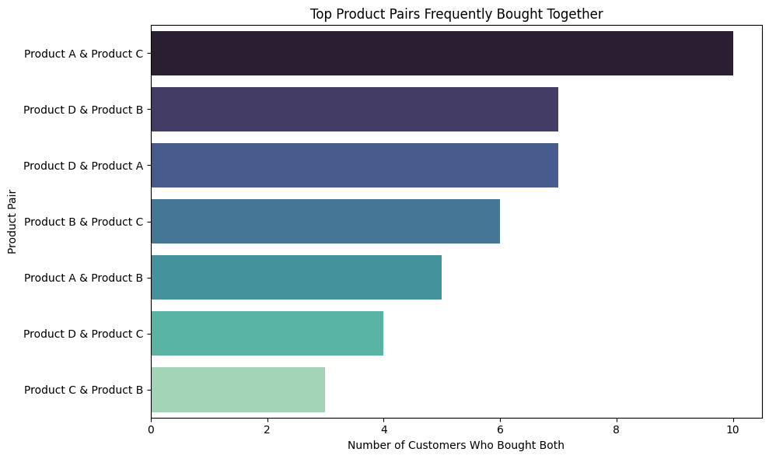

1. **Without direct feedback data, how would you use indirect feedback such as repeat purchases and product returns to refine RFM segmentation and improve customer satisfaction?**

**Ans: # Track product-level repeat purchase rates:**

**# Customers with more than one order**

**repeat_buyers = df_cleaned.groupby('CustomerID')['OrderID'].nunique().reset_index()**

**repeat_buyers['Is_Repeat_Buyer'] = repeat_buyers['OrderID'] > 1**

**repeat_buyers['Is_Repeat_Buyer'].value_counts()**

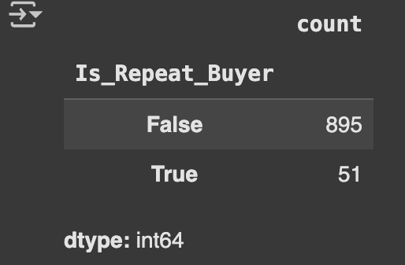

**Analytical Approach:**

* Customers were grouped by CustomerID and the number of unique OrderIDs was calculated.
* A binary column Is_Repeat_Buyer was created to classify customers with more than one purchase (True) versus single-time buyers (False).
* Only 5.4% of the total customer base (51 out of 946) placed more than one order.

**Key Insights:**

1. **Low Repeat Rate Signals Retention Weakness:**

* A repeat buyer rate of 5.4% is significantly low, especially in industries where 20–30% repeat rates are standard.
* This suggests that many first-time buyers do not return, potentially due to unmet expectations, lack of engagement, or insufficient follow-up.

1. **High Concentration of Value in Low Repeat Group:**

* Given the earlier RFM findings where Champions, Big Spenders, and Loyal segments accounted for a large share of revenue, this implies that even within these high-value groups, repeat purchases are rare.
* There may be one-time bulk buyers, rather than loyal returning customers.

1. **Feedback Loop Missing:**

* In the absence of return flags or reviews, the absence of repeat orders itself acts as negative feedback, especially when combined with recency and monetary value.

**Recommendations for RFM Refinement & Satisfaction Strategy:**

#### **Create a Repeat Buyer Flag in RFM Model:**

* Add a binary attribute to customers indicating whether they are repeat buyers (True) or not (False).
* Prioritize high RFM customers who are not repeat buyers for **experience audits** or **personalized retention strategies**.

1. **Reclassify ‘Champions’ Without Repeat Purchases:**

* Customers labeled as ‘Champions’ with high Recency and Monetary but low Frequency should be flagged for follow-up engagement:
  + Send “How was your experience?” emails.
  + Offer post-purchase incentives like loyalty enrollment, referral bonuses, or personalized offers.

1. **Use Repeat Rate as an RFM Quality Overlay:**

* Segment loyalty further based on engagement depth, not just recency:
* For example: A customer with R=4, F=1, M=4 might have spent ₹10,000 last week, but not returned yet.
* Flag this as “High Potential – Needs Nurturing.”

1. **Design Repeat-Centric Campaigns:**

* Launch retention triggers such as:
* “Complete Your Second Purchase and Get 20% Off.”
* “Your Last Order Was 30 Days Ago – Ready for the Next One?”
* Loyalty points that activate only from second purchase onward.

#### **Analyze Repeat Product Patterns (Future Enhancement):**

* Identify which products are most likely to lead to repeat behavior and promote them as gateway products.
* Apply propensity modeling based on sequence of purchase events.

**Conclusion:**

* Analysis of repeat purchases shows that only about 5.4% of customers made more than one purchase. While this repeat buyer group is small, it represents a highly valuable segment that has shown loyalty without needing additional incentives or support.
* These customers should be nurtured with exclusive rewards, early access to sales, and loyalty programs to retain and grow their engagement. On the other hand, the 94% who made only a single purchase could be experiencing pain points (e.g., product fit, delivery, pricing) that discourage retention. These insights help us fine-tune RFM segments and guide targeted re-engagement strategies all derived from behavioral signals without needing direct feedback or return data.

1. **How would you analyze the revenue variation by day of the week for different RFM segments to identify patterns and optimize marketing efforts?**

**Ans:**

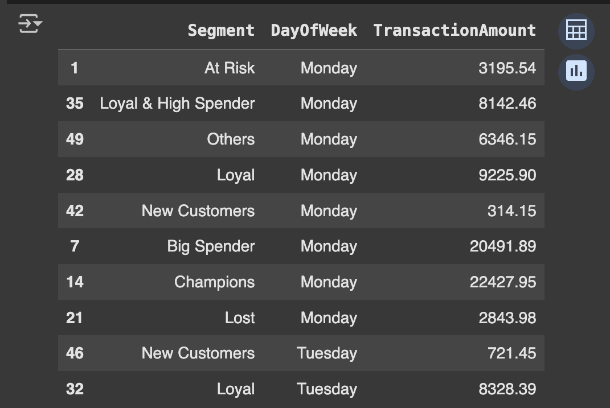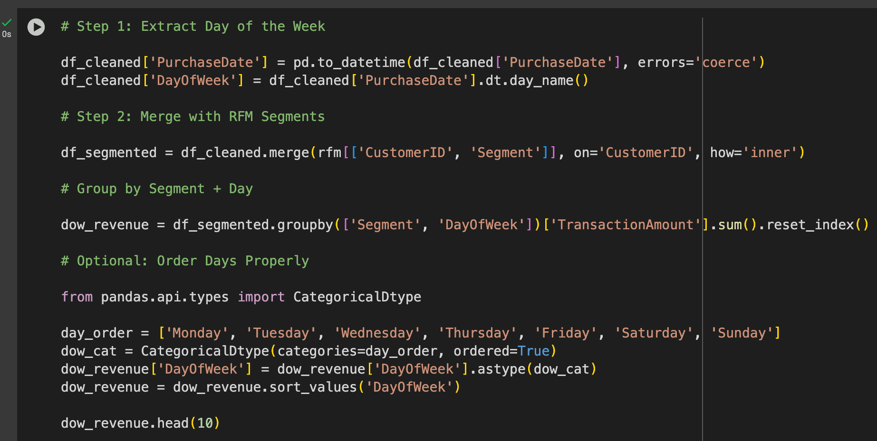

**Analytical Approach:**

1. Converted PurchaseDate to datetime format and extracted the day of the week into a new column DayOfWeek.
2. Merged the cleaned transactional dataset with RFM segmentation to associate each purchase with the corresponding segment.
3. Grouped the data by both Segment and DayOfWeek, and aggregated total TransactionAmount.
4. Applied a categorical order to the DayOfWeek to ensure correct plotting from Monday to Sunday.

**Key Insights:**

1. **High Engagement Early in the Week:**

* Monday emerges as a strong revenue day for Champions (₹22.4K), Big Spenders (₹20.4K), and Loyal customers (₹9.2K).
* Indicates that high-value segments are more likely to transact at the start of the workweek, potentially after weekend browsing or promotions.

1. **Low Activity from New Customers:**

* Minimal revenue from New Customers on any given day, suggesting limited onboarding success or engagement post-acquisition.
* Monday and Tuesday revenue from this group are below ₹800.

1. **At Risk and Lost Segments Still Active:**

* Despite being inactive or disengaged, At Risk and Lost segments contribute some revenue on Mondays, making this a strategic re-engagement window.

1. **Segment-Specific Fluctuations Exist:**

* Revenue trends are not uniform across segments, reinforcing the need for day-specific targeting rather than one-size-fits-all campaigns.

**Recommendations:**

1. **Launch Segment-Timed Campaigns:**

* **Champions & Big Spenders:**
* Launch exclusive early-week offers (Mon–Tue) such as "VIP Monday Deals" or early access to product drops.
* Reinforce loyalty with tailored appreciation messages early in the week.
* **Loyal & High Spender:**
* Target mid-week reminders (Tue–Wed) to maintain engagement and upsell bundled offers.
* **At Risk & Lost:**
* Schedule reactivation campaigns for Monday when these segments show comparatively higher engagement.
* Include incentives like free shipping, flash coupons, or "We Miss You" bundles.
* **New Customers:**
* Schedule onboarding email sequences for Tuesday or Thursday, guiding them through product features, first-purchase coupons, and “starter bundles.”

1. **Personalized Push Notifications or Emails:**

* For Champions and Big Spenders, schedule morning push notifications or emails on Mondays to capitalize on their peak transaction window.
* Include messages like:
* “Start Your Week with Something Special”
* “Just for You – This Week’s Handpicked Picks”

**Conclusion:**

High-value customers, particularly Champions and Big Spenders, are most active on Mondays, making it the ideal day for engagement and conversion strategies. Conversely, low-value and new customers require more nurturing and may benefit from campaigns on less competitive days like Wednesday or Thursday. A day-parted marketing strategy that aligns with these behavioral insights can significantly improve engagement, optimize campaign efficiency, and enhance customer satisfaction.

# Visualize the Revenue Pattern

plt.figure(figsize=(12, 6))

sns.lineplot(

data=dow_revenue,

x='DayOfWeek',

y='TransactionAmount',

hue='Segment',

marker='o',

palette='tab10'

)

plt.title('Revenue by Day of the Week for Each RFM Segment')

plt.xlabel('Day of the Week')

plt.ylabel('Total Revenue')

plt.xticks(rotation=45)

plt.grid(True)

plt.tight_layout()

plt.show()

